[WOBI-21] Pages of 2 insurance companies couldn´t be open Created: 24/Feb/24 Updated: 24/Feb/24
Status: | To Do
Project: | Wobi

Type: | Bug | Priority: | High
Reporter: | Tomer Darmon | Assignee: | Tomer Darmon
Environment: | Browser :  Chrome Version 121.0.6167.140  Firefox Version 122.0.1  Microsoft Edge Version 121.0.2277.106
Attachments: | 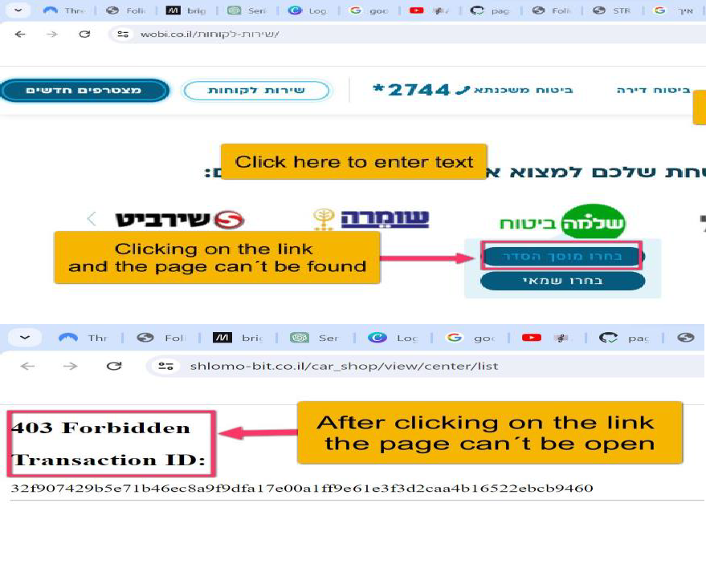
Severity: | S2- Critical

Description
Steps to Reproduce :
- Enter the URL https://www.wobi.co.il/
- Press on the tab “לקוחות שירות” on the top left side
- Scroll down until you reach to the title that say : “ את“ למצוא שלכם המבטחת החברה של הלינק על הקליקו
מוסכי ההסדר/השמאים
- Go over with the mouse on the icon of the insurance company “שומרה” and press
בחרו מוסך הסדר tab the on
- You can try the same process with the insurance company next to it “ביטוח שלמה”
Actual Result: We get a message that the page can´t be found or it is error 403
Expected Result: We are expecting that the page will be open and show the offer of each car insurance company
38

